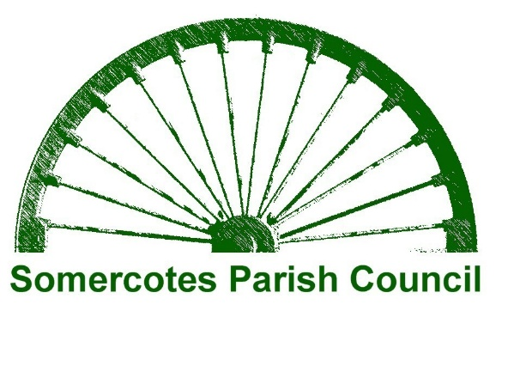

PARISH MEETING

Friday 15th MAY 2026

Somercotes Parish Hall

COMMENCING AT 6-00PM

ALL ELECTORS FOR THE PARISH OF SOMERCOTES ARE ENTITLED TO ATTEND THE ABOVE MEETING, PLACE ITEMS ON THE AGENDA AND VOTE.

IF YOU WISH TO PLACE AN ITEM ON THE AGENDA YOU MUST WRITE TO ME, AT SOMERCOTES PARISH COUNCIL
NO LATER THAN MIDNIGHT on Sunday 10th May 2026.
ITEMS RECEIVED SO FAR ARE:
- TO HEAR AN ADDDRESS FROM COUNCILLOR JASON PARKER CHAIRMAN
- TO READ AND CONSIDER THE MINUTES OF THE ANNUAL PARISH MEETING 2025
- TO HEAR ITEMS FROM MEMBERS OF THE PUBLIC

SIGNED
T Crookes
Tina Crookes, Parish Clerk
Dated 6th May 2026

